SWVL APP

**User Guide**

Project Members:

***Salman Ahmed Khan (19K-1043) - BS SE (A)***

***Khizar Jilani (19K-1057) - BS SE (A)***

***Hasnain Abbas (19K-1059) - BS SE (A)***

***Sadeem Sattar (19K-1102) - BS SE (A)***

***Abdullah Tilal Khan (19K-1103) - BS SE (A)***

Dated: November 5, 2021

Contents

**Introduction** 3

**Downloading and Installing** 3

**How to Download:** 3

**Installation and Access:** 5

**Account Registration** 6

**Registration Setup** 6

**Booking a ride:** 9

**Setting up location:** 9

**Adding a destination:** 10

**Confirming a ride and checking details:** 13

**Cancelling a ride:** 17

**Payment Method** 19

**Credit/ Debit Card Method** 19

**Cash Method** 20

**Amount Wallet** 21

**Available Packages** 22

**Edit Account Settings** 24

**Support Help** 25

**Get Free Rides** 27

# **Introduction**

Swvl is a mobile application that provides transport facility to its users. It is an Egyptian bus transportation company which operate in more than five countries including Pakistan. It provides profile registration, searching, booking and payment as a core functionality. It also provides available packages, free rides and a support chat through which users can submit their concerns.

Swvl is an online application that allow users to book a bus ride to reach their destination. It requires users to create their account on swvl app. A user can search for the desired destination location to reach. The swvl provides available buses through which user may select and book the bus. A ticket is generated which include the bus details and the pickup details. A user can pay for the ride through debit/ credit card, swvl wallet or by cash after the completion of the ride.

# **Downloading and Installing**

The Swvl app download require a steady and stable internet connection to download and install in the cellphone.

## **How to Download:**

* Click on the Play Store app to download the Swvl app. The play store app is located on the home page of the cell phone as shown below.

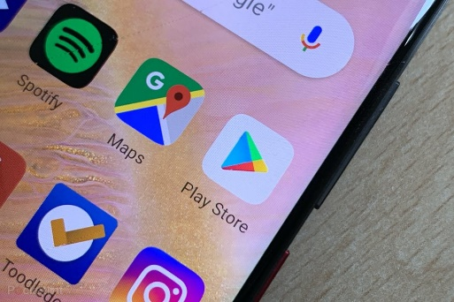

* After clicking on the play store icon, the home page of the play store will open. At the top of search bar type **Swvl**. Click on the Swvl icon menu below.

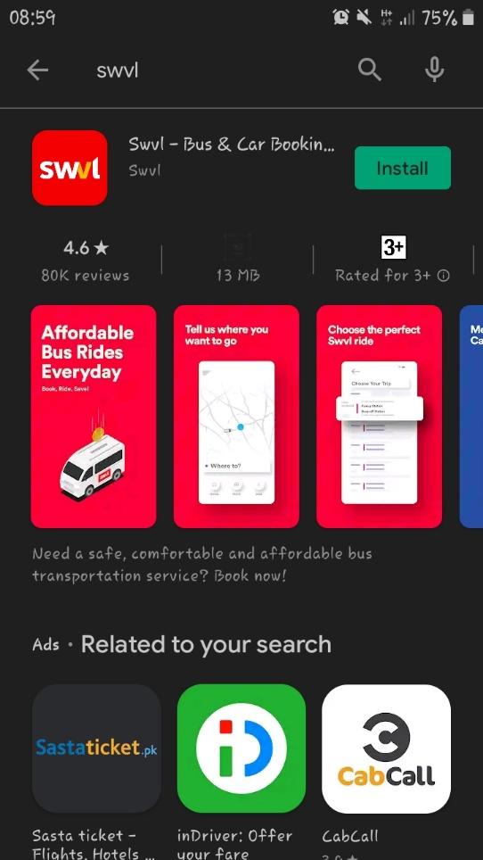

* Click on the install button located at the bottom, below the icon menu description to download and install the app.

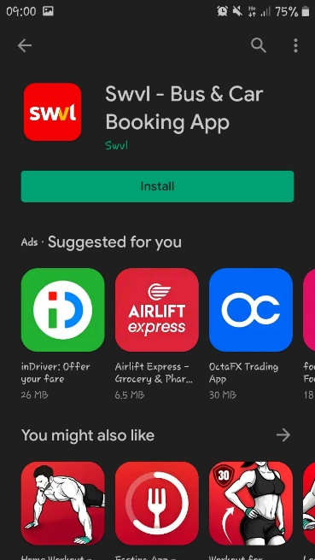

## **Installation and Access:**

After successfully downloading and installing the app, do the following

* Click on the open button located at top right below the icon menu description

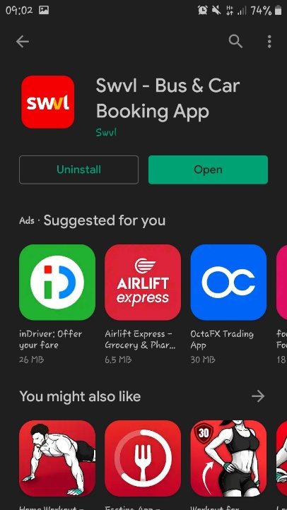

* After opening the Swvl app, select Allow to provide location access to Swvl app.

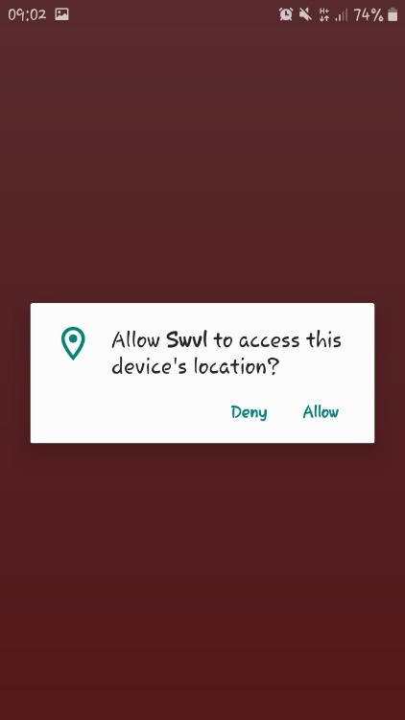

Caution:

* If the access is not provided, then the swvl app will not proceed to further process

# **Account Registration**

Swvl app requires the registration of the user to further proceed for the transportation facility. It is the primary requirement to use the app.

## **Registration Setup**

* In the bottom type bar, provide your mobile number to setup account.

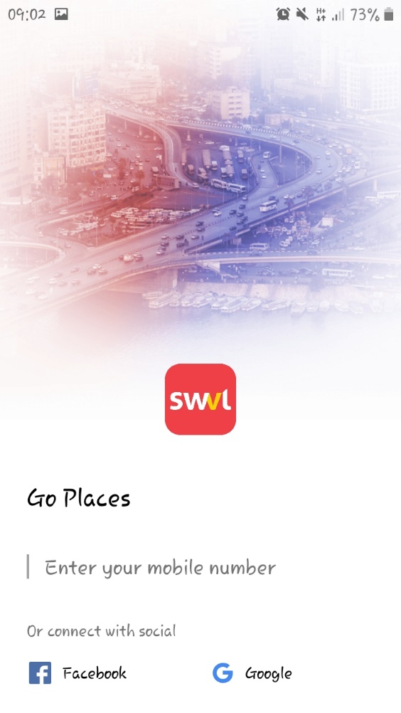

Note: Account can also setup using social media application including Facebook and Google

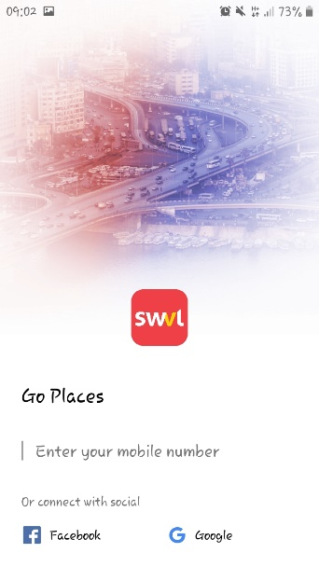

* Select your country code and enter your mobile number. Click ‘>’ sign to proceed.

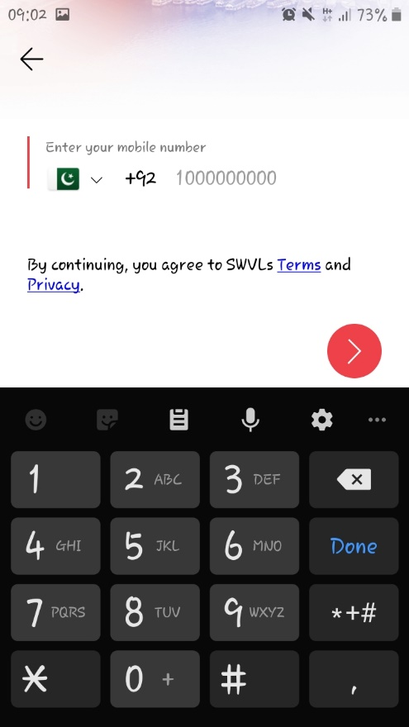

* After entering mobile number, enter your desired password to register and login to your Swvl home page. Click on ‘>’ sign to proceed.

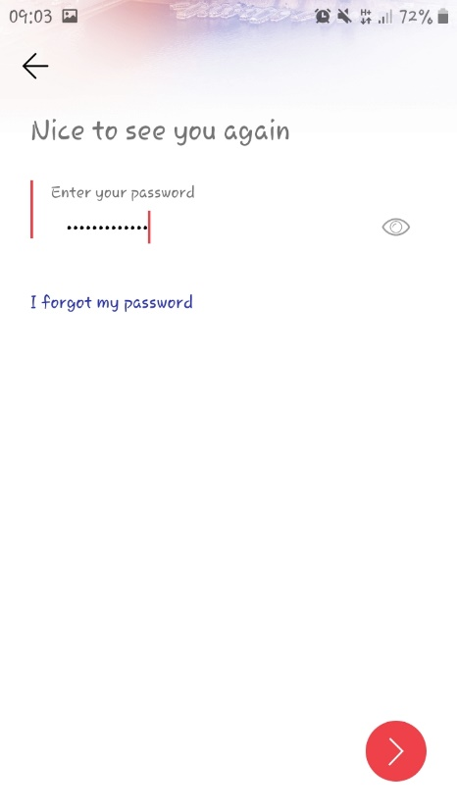

Note: If you forget your password then click on **‘I forget my password’** highlighted panel below to get recovery email for new password.

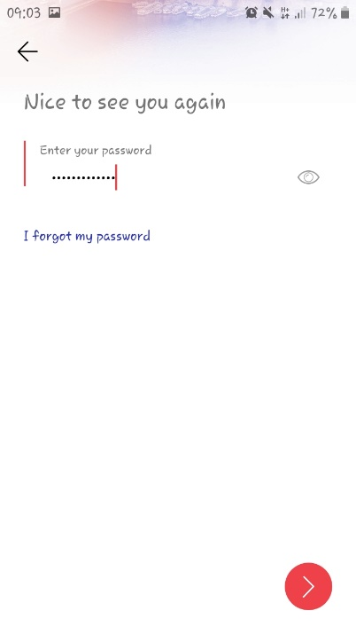

# **Booking a ride:**

We will show step by step how to book a ride using Swvl from setting up your location to booking and cancelling ride once it is booked.

## **Setting up location:**

* Once you are finished setting up your Swvl account, you can proceed to Swvl user application interface. Here, you can browse map of your city showing all locations.
* You can browse different locations using map.
* Also, you will see a notification asking you to turn on your location as shown in picture below. You have to click it and Swvl will automatically find and save your location using GPS.

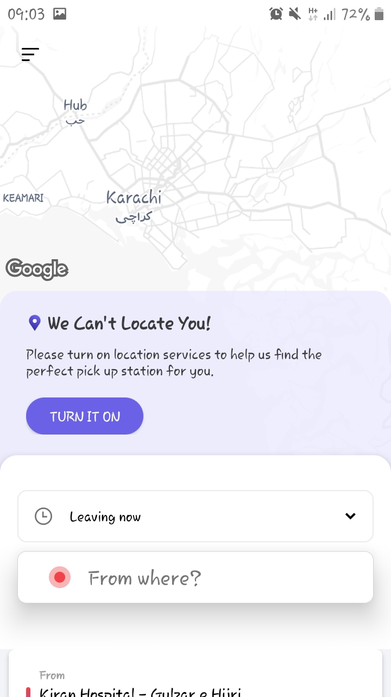

* Once you have clicked on turn on location button, your location will be saved by Swvl and it will help you booking rides by showing you nearby available rides. Also, you will also be able to see that your current location has been saved as shown in below picture.

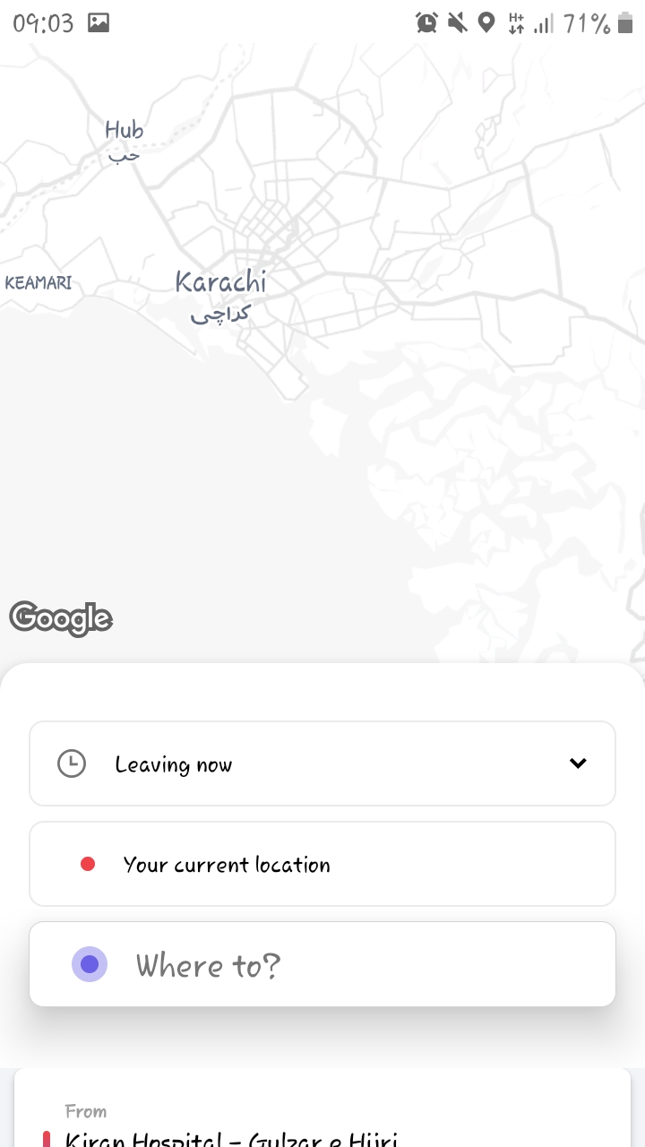

## **Adding a destination:**

* Once your location is saved, you can proceed to provide your destination. You will see two fields to be filled, one is form where which is your current location and other is where to, which is your destination as shown below.

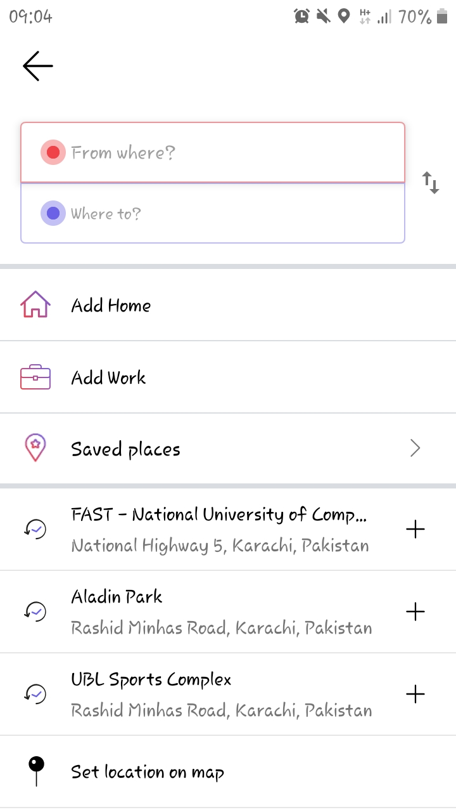

* Since you have already provided your location, you just have to click on where to field and your current location will automatically added in it.
* Alternatively, you can provide by simply typing it in from where field or choosing home, work, other saved places option which you can bookmark as shown below.

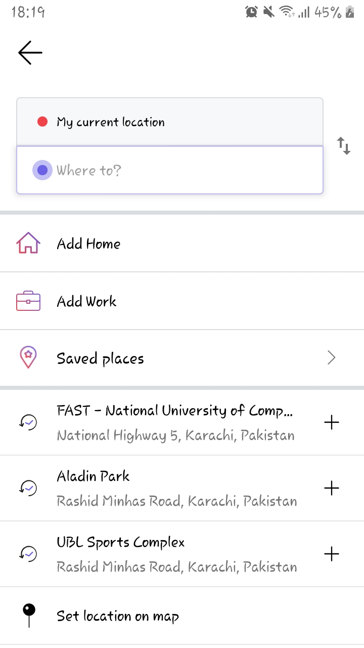

* You can provide your destination simply by typing it in to where field. Once you start typing, you will see suggestions based on your entered location and you can click on any suitable location to set that location as your destination as shown in picture below.

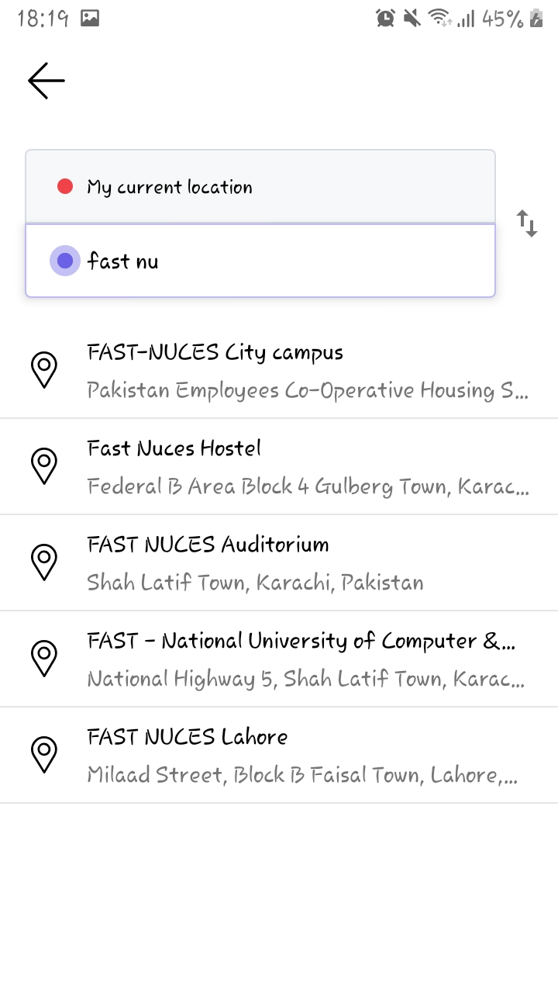

## **Confirming a ride and checking details:**

* Once you have provided your destination, you will see a window showing nearby available rides, their fares and arrival and estimated time of your journey. You can also click on days-button on top to book a ride in advance as shown below.

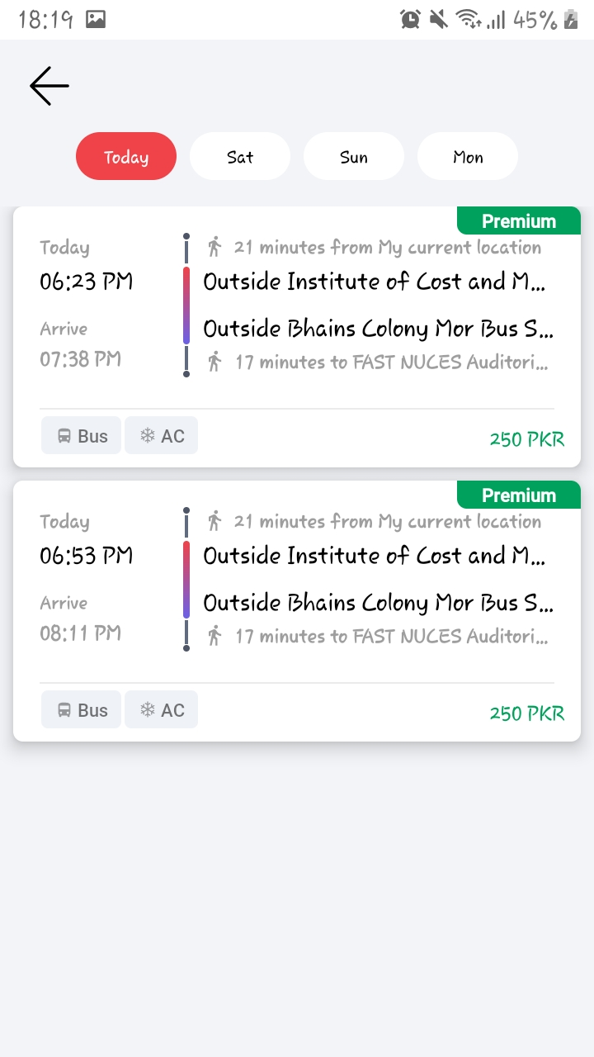

* You can choose any ride which suits you best. Consequently, you will see another window showing your current location and destination on map, also the route that will be taken to drop you at your destination. You can click on + seat sign on middle to increase number of tickets you want to book or – sign to decrease number of tickets you want to book.
* You can click on promo code button on top to apply a promo code to receive discount on your fare if promo code is available. Total calculated fare will be shown in Fare option.
* You can also specify which method you want to use to pay for your fare as shown in below picture.

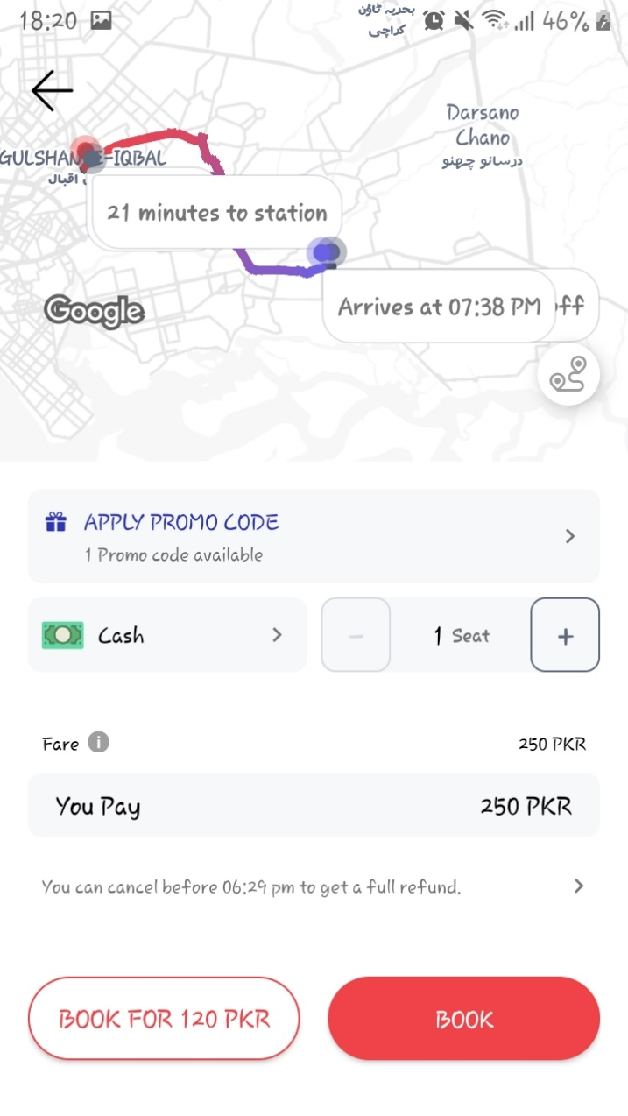

* You can click on book button to book your ride.
* After clicking on book button, you will see window notifying you of booking of your ride. You can click on check trip details button to view your trip details or book return ride button to book another ride in advance as shown in picture below.

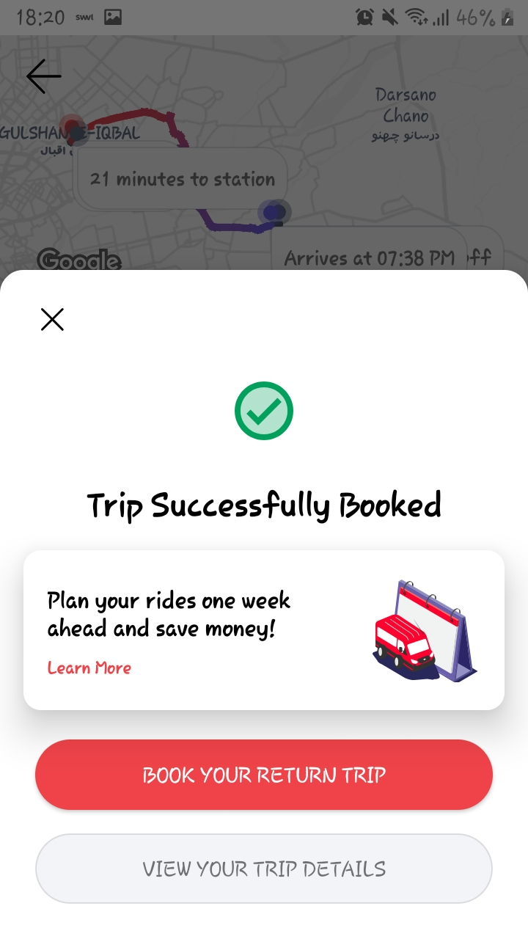

* After clicking view ride details button, ride details and vehicle details will be displayed along with your boarding pass which will be displayed on top that act as your ticket number.
* You can call your ride captain if you want to ask about any query by clicking on call button as shown below.

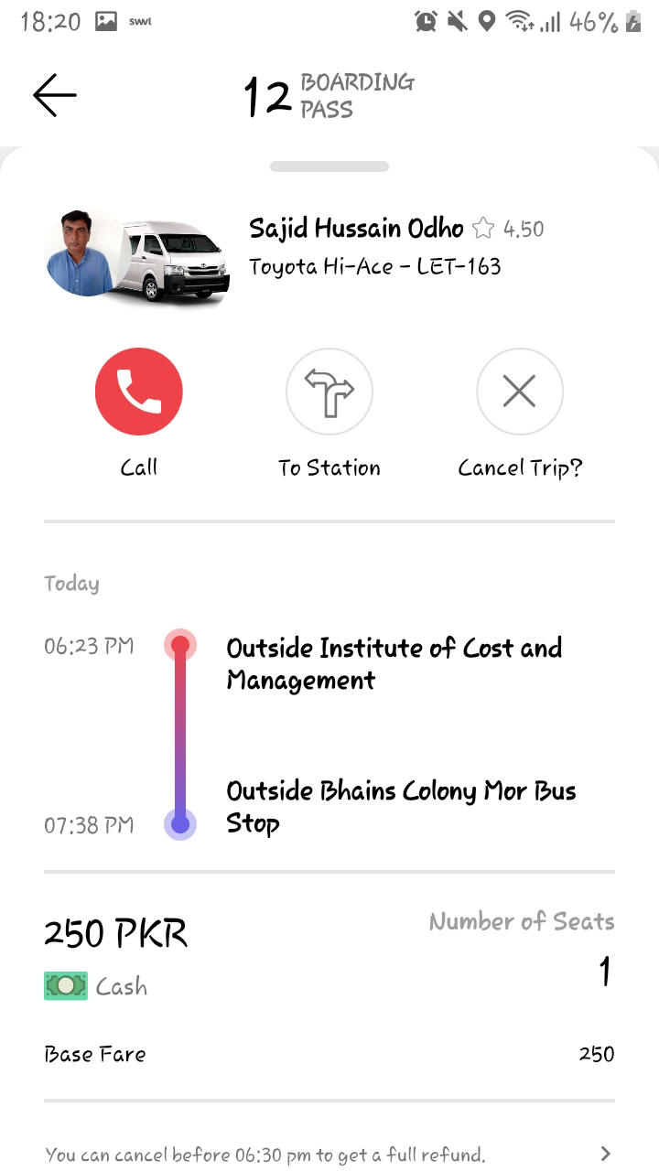

# **Cancelling a ride:**

* If you want to cancel a ride, you can click on cancel trip button on top left as shown in above picture.
* You will be asked to confirm your cancellation by clicking on cancel trip button. You can click back button if you mistakenly clicked cancel trip button and wish to book a ride.

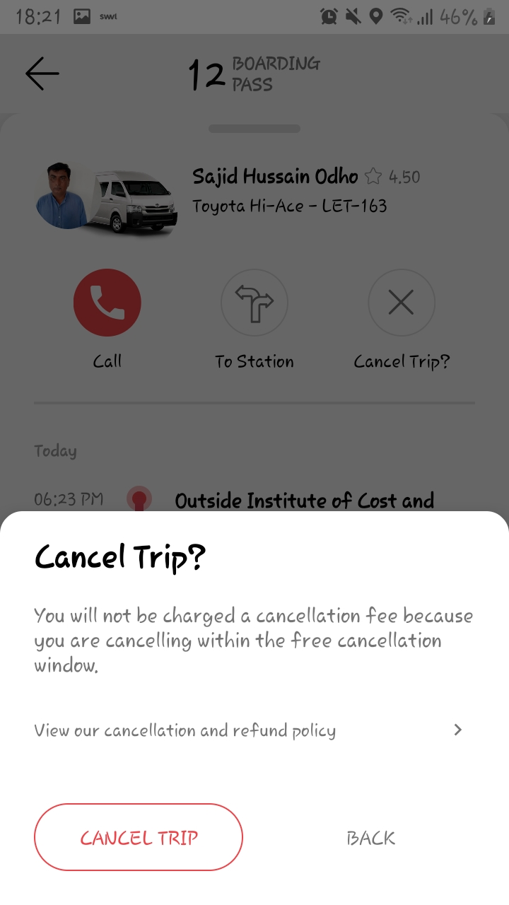

# **Payment Method**

Swvl Provides two type of payment method which include credit/ debit card and cash method.

## **Credit/ Debit Card Method**

* Click on the menu panel located at top left corner as shown below.

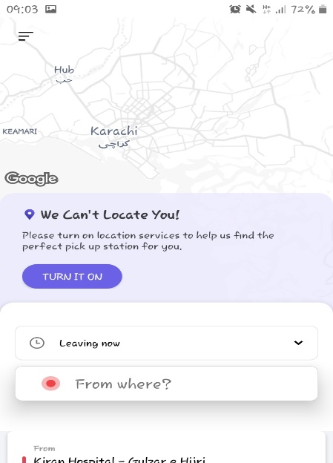

* The menu panel will appear in which select the Payment section as shown below.

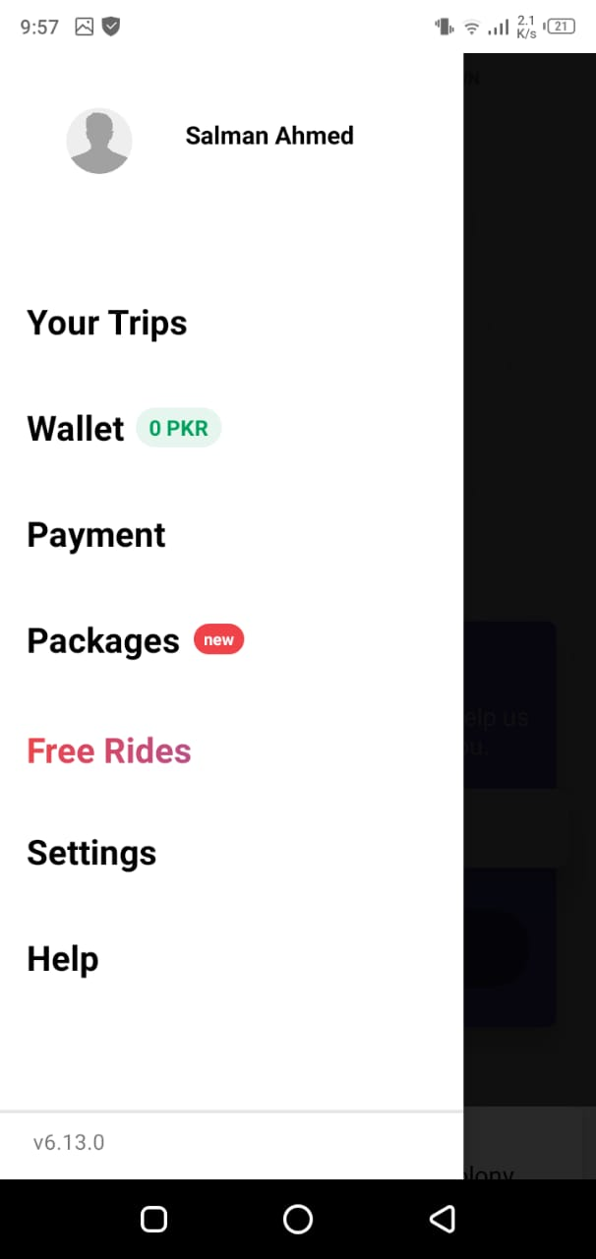

* Click on the Add debit or credit card payment method.

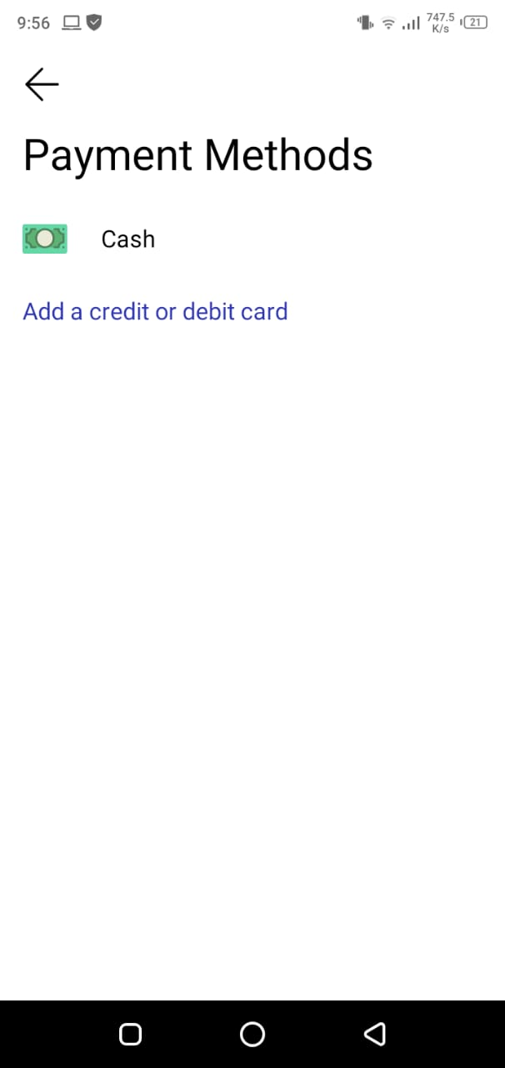

* Enter your card details and click on **Add Card** button located at bottom to save the information.

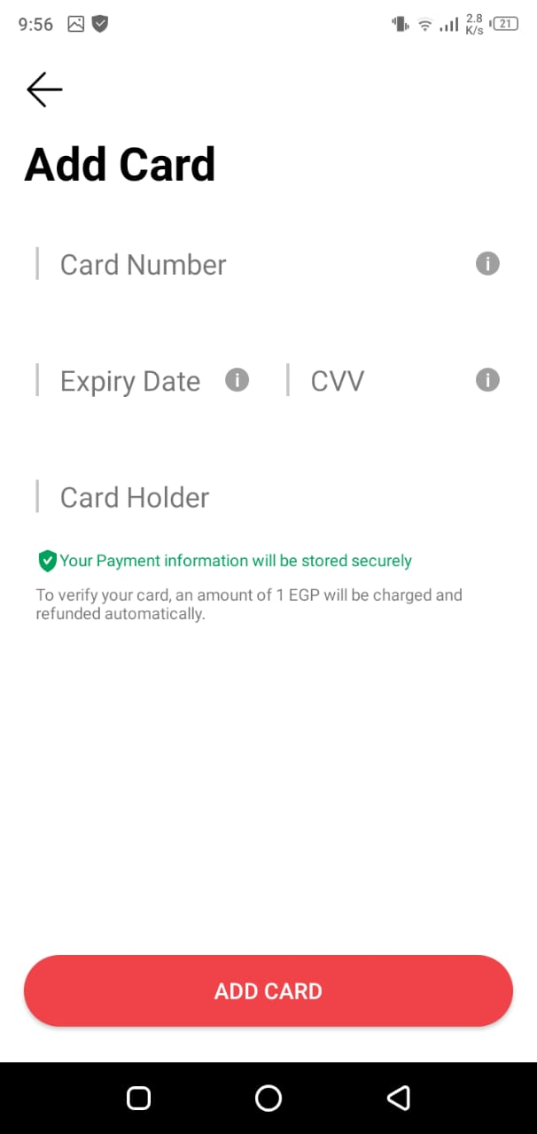

## **Cash Method**

* The cash method information is not required as the cash will be provided to the ride captain in hand.

# **Amount Wallet**

The late fee and change amount are stored in the Swvl wallet which will be deducted at the end of the ride.

How to view amount in the wallet

* Click on the menu panel located at top left corner as shown below.



* The menu panel will appear in which select the Wallet section as shown below.

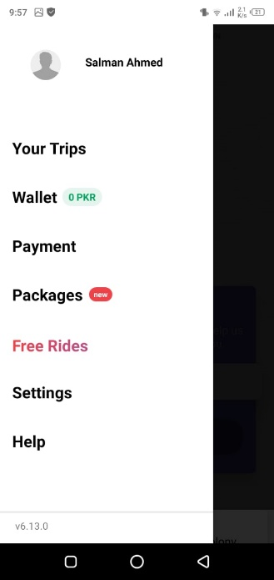

* The wallet section will appear indicating the available amount in your wallet credit.

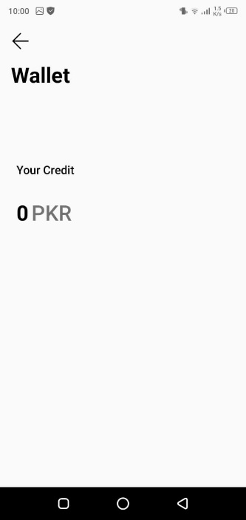

# **Available Packages**

Swvl also provides packages to fit for the customer requirement to avail it. The packages contain discount and the reduction in the ride prices.

* Click on the menu panel located at top left corner as shown below.



* The menu panel will appear in which select the Packages section as shown below.



* The package section will appear indicating the available packages and their prices.

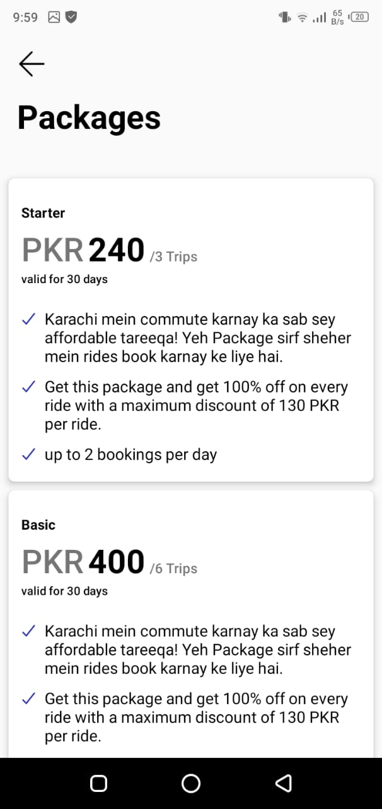

# **Edit Account Settings**

The Swvl app provides the account settings to re-enter your credential.

Set Account Details

* Click on the menu panel located at top left corner as shown below.



* The menu panel will appear in which select the Settings section as shown below.



* The setting panel allow user to re-enter user’s details by clicking on the pencil icon as shown below.

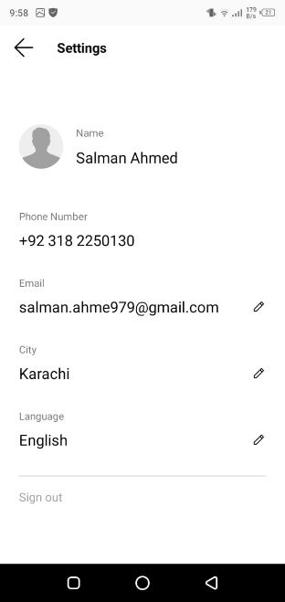

# **Support Help**

The Swvl App also provide functionality for the users to resolve their queries by providing a support chat feature.

How to access support feature

* Click on the menu panel located at top left corner as shown below.

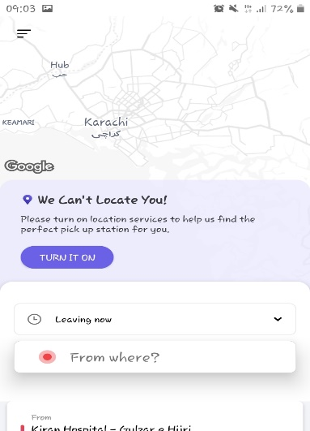

* The menu panel will appear in which select the Settings section as shown below.



* The Help panel allow user to chat with the Swvl support team for resolving queries as shown below.

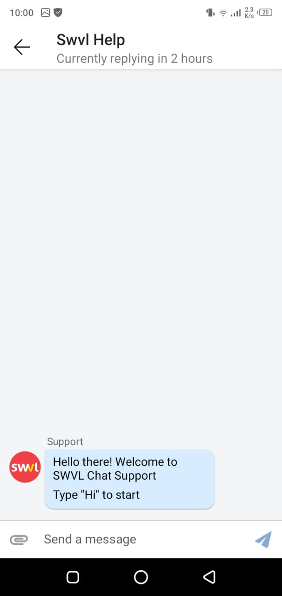

# **Get Free Rides**

The Swvl app provide the facility to its users to have a free ride by referring the Swvl app to their friends and family members and upon their first ride, the cash will be transferred to the wallet of the user.

* Click on the menu panel located at top left corner as shown below.



* The menu panel will appear in which select the Free Rides section as shown below.



* The free rides panel allow user to share their referral code and the link as shown below.

